MATERIALS USED
A4 Paper
Single Laminating Sheets
Cardboard
Clipart pictures
Card Construction
I chose images that young children would understand.
I printed them out on coloured card and stuck them onto thicker card.
The cards were then laminated to make them more durable.
These cards can be used by teachers and students alike.
Set One
Count on by adding 0,1,2,3 | 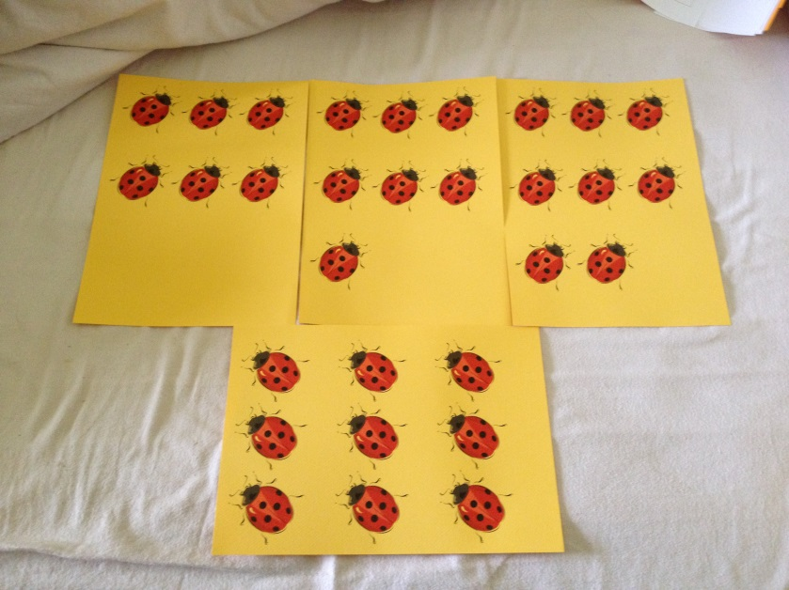 | 63 x 50.7 cm
Double/halving | 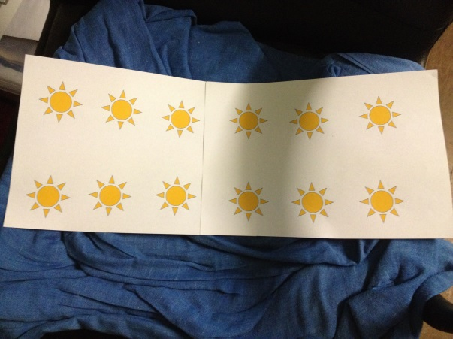 | 60 x 21 cm
Use 10 | 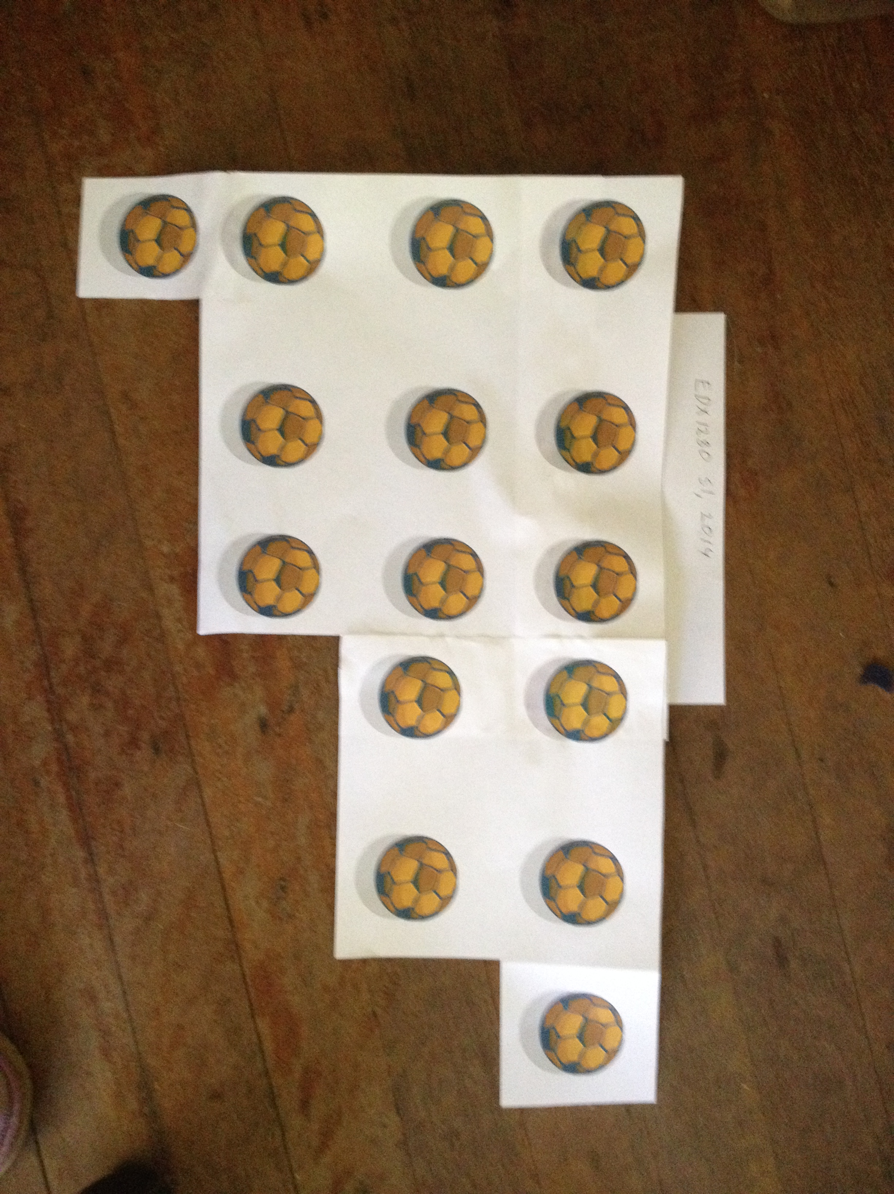 | 49 x 32 cm

Set Two
Build up/Down | 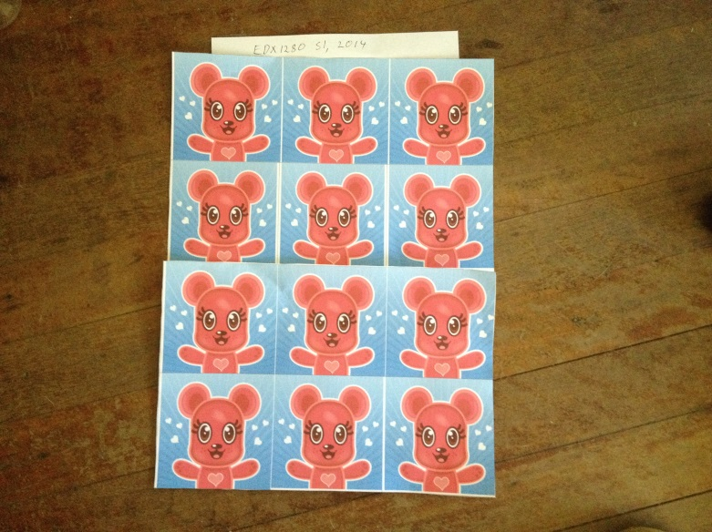 |  | 27 36 cm
Real world | 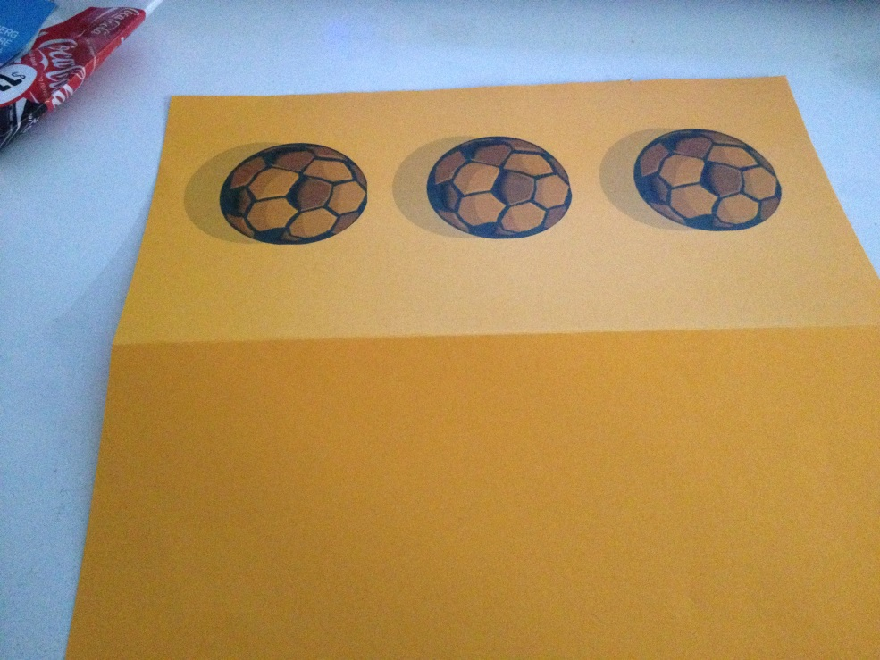 |  | 21 x 21.5 cm
Doubling | 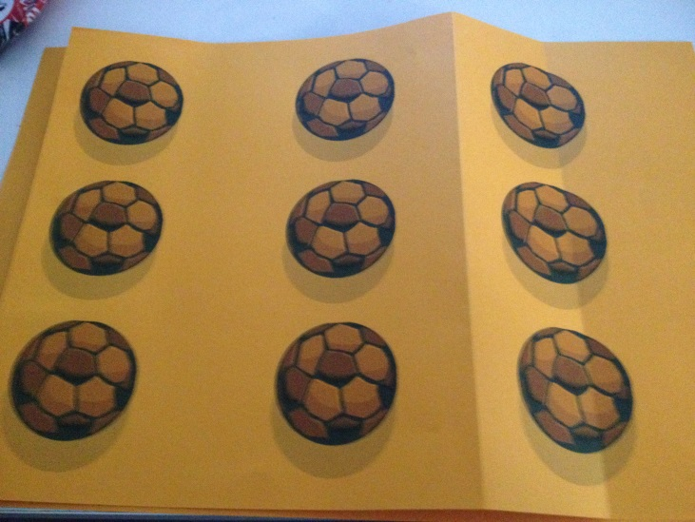 |  | 21 x 29.5 cm
Counting by 5 |  | 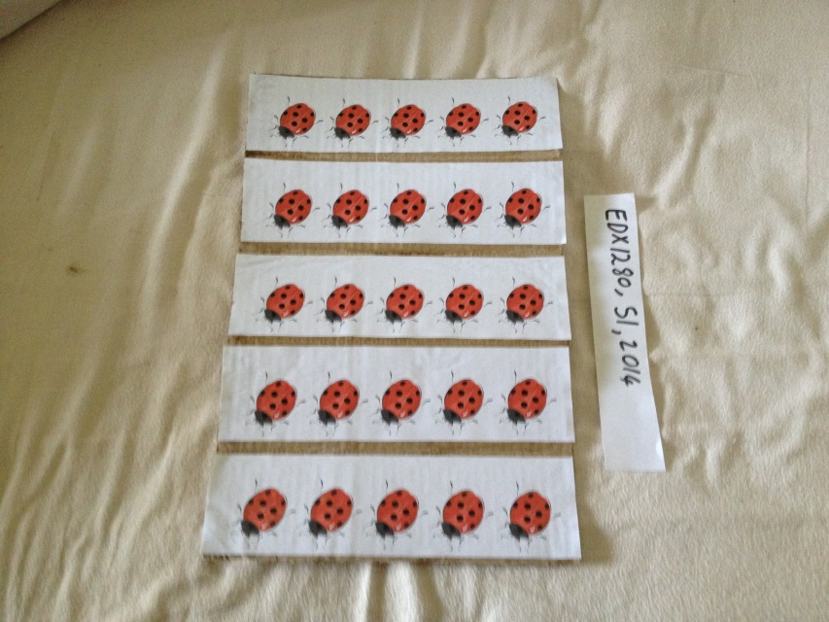 | 24 x 37 cm

